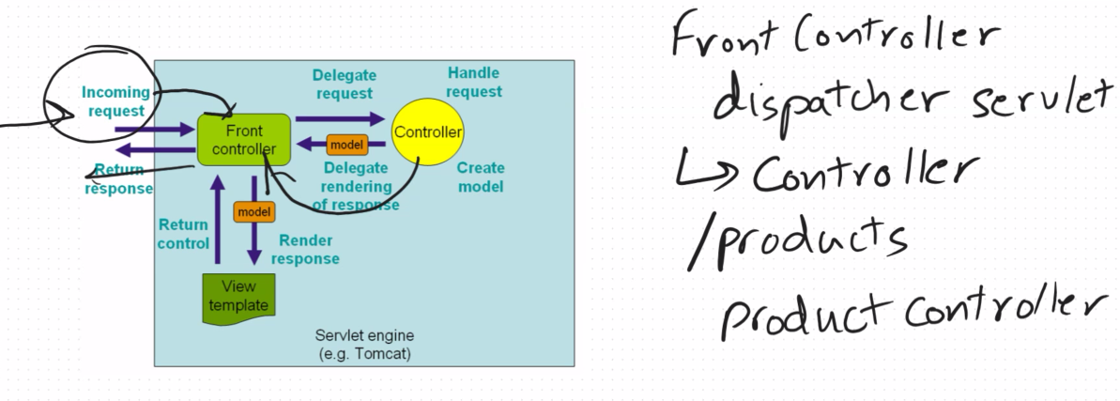

<https://docs.spring.io/spring-boot/docs/1.1.6.RELEASE/reference/html/common-application-properties.html>

<https://docs.spring.io/spring-boot/appendix/application-properties/index.html>

Hellocontroller

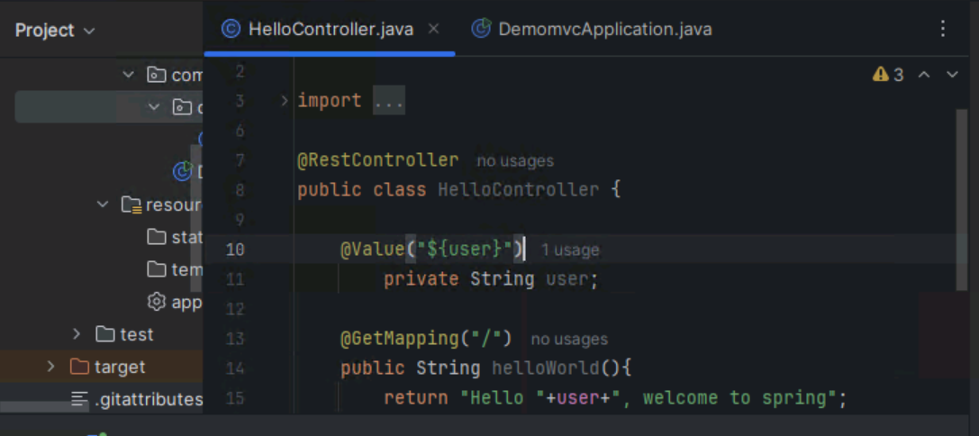

Application Properties

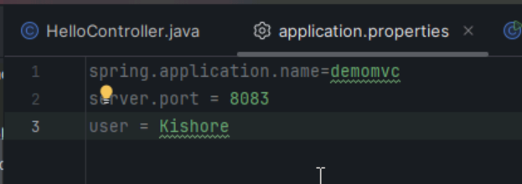

Changing the embedded server

Exclucding tomcat and including jetty web

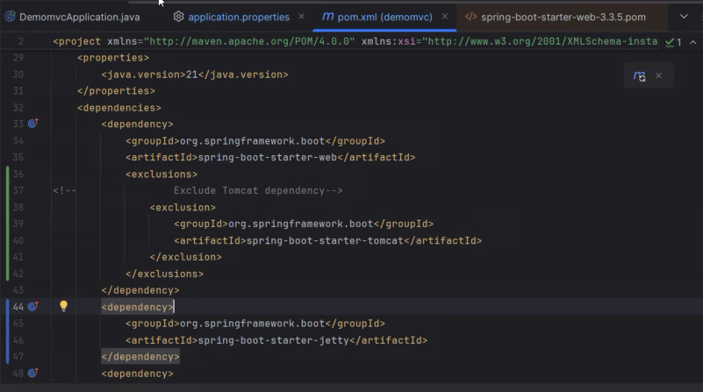

<https://docs.spring.io/spring-boot/how-to/webserver.html>

Building a CRUD Products App

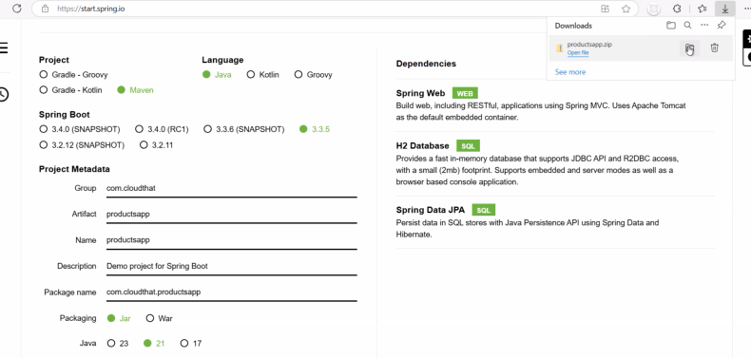

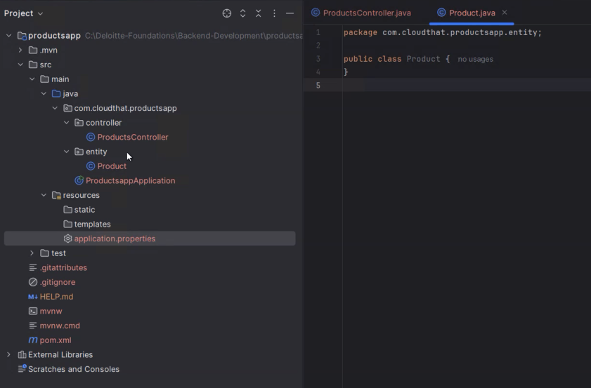

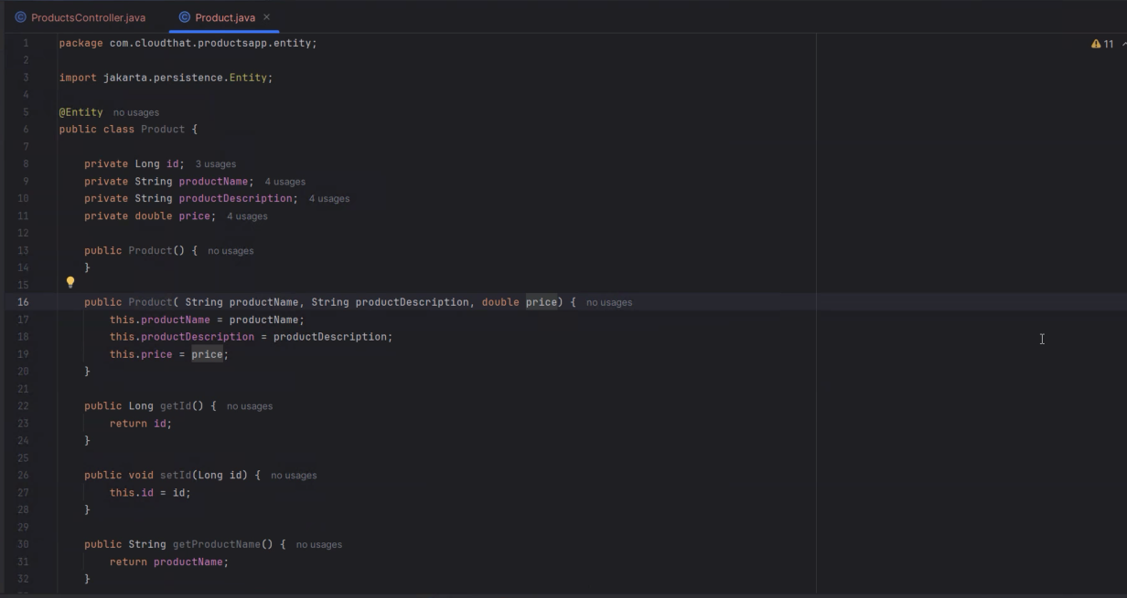

Generate no argument constructor and all argument constructor and getter, setters and to string method

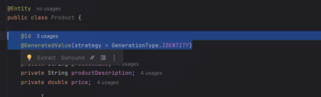

@Id  
    @GeneratedValue(strategy = GenerationType.IDENTITY)

@Entity

* This annotation is used to mark a java class as Entity, meaning it is a JPA(Java Persisence API) entity.
* Once method, the class will be mapped to a table in the database.
* Eg: If you have a class User annotated with @Entity, JPA will create a table for User (or map it to an existing one).

@Id

* This annotation is used to specify the primary key of the entity.
* The field marked with @Id will act as a unique identifier for each record in the table.

@GeneratedValue

* This annotation is typically used in conjunction with @Id to specify that the value of the primary key should be generated automatically.
* Different strategies for generating the ID like, AUTO, IDENTITY, SEQUENCE and TABLE.

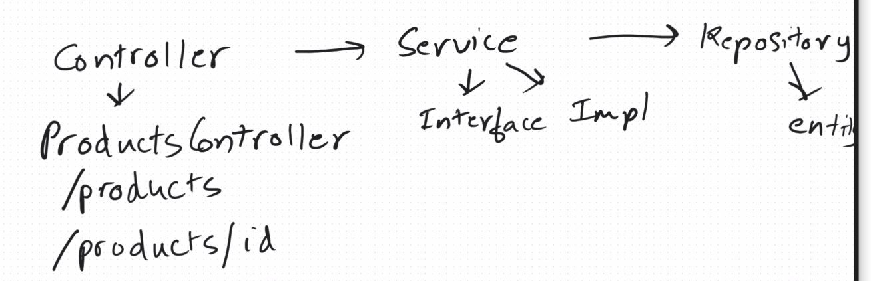

Everything should be separate for better debugging, testing etc..

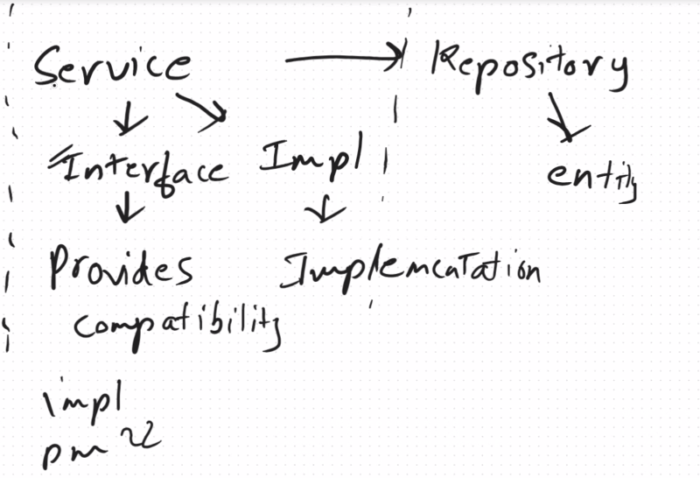

Create another package model and entity separate

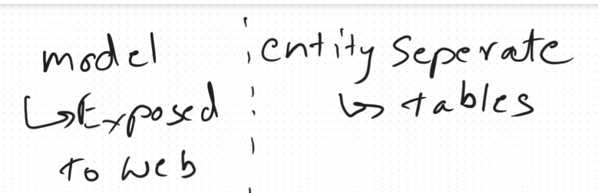

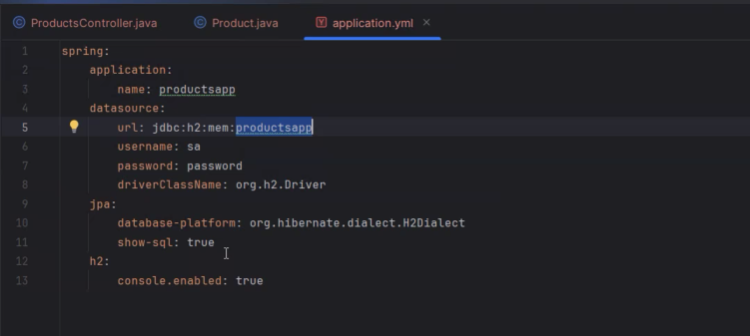

You can find this in spring website under data access section

<https://docs.spring.io/spring-boot/how-to/data-access.html>

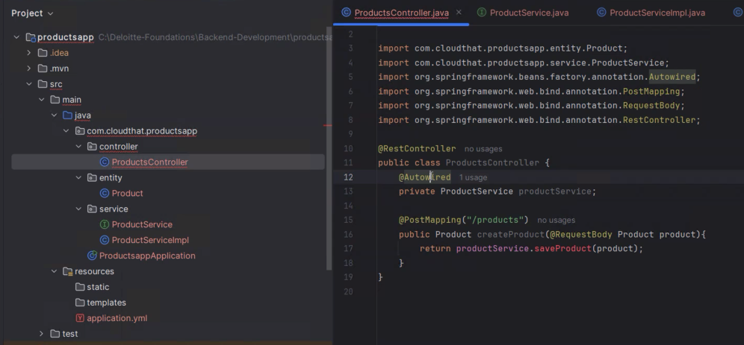

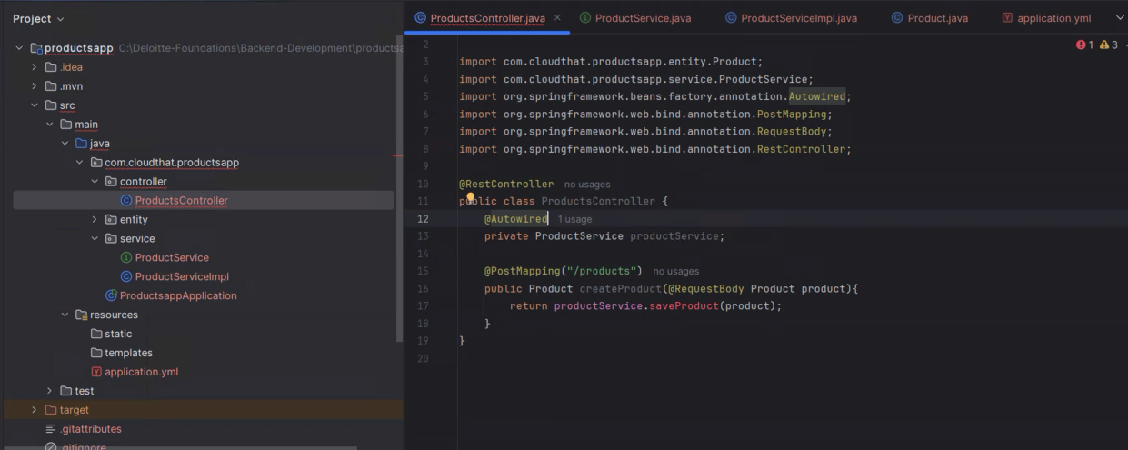

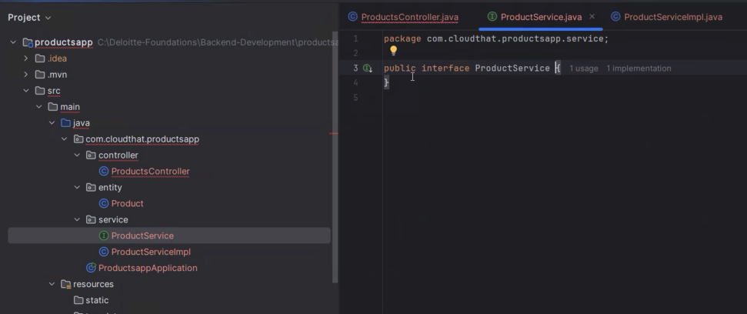

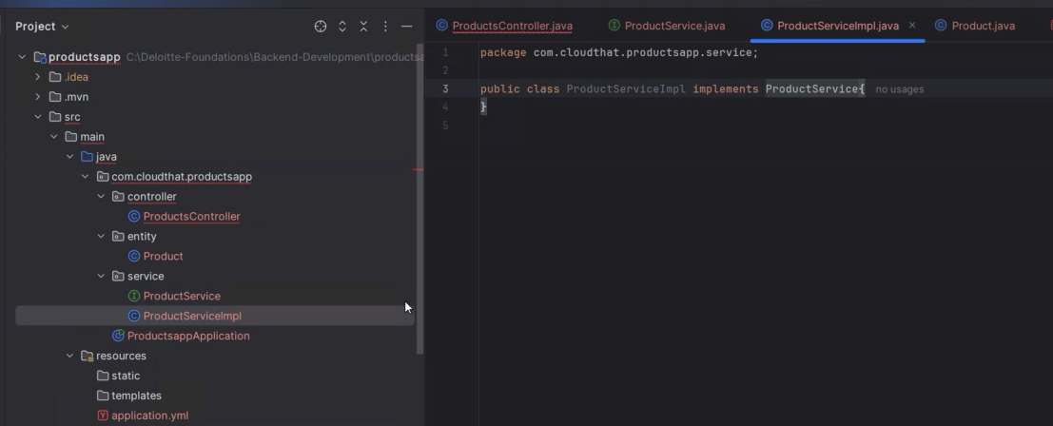

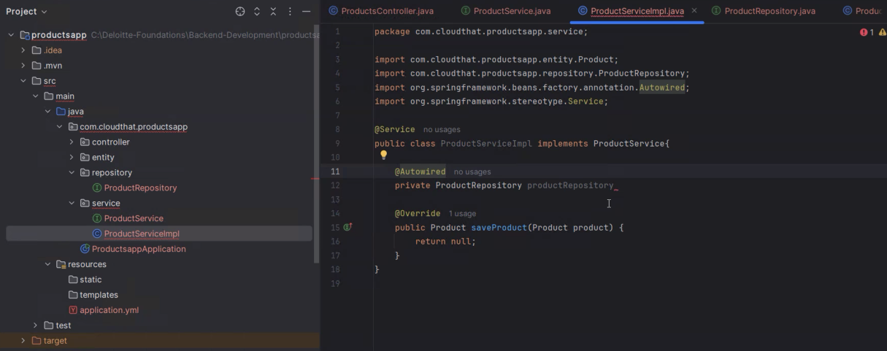

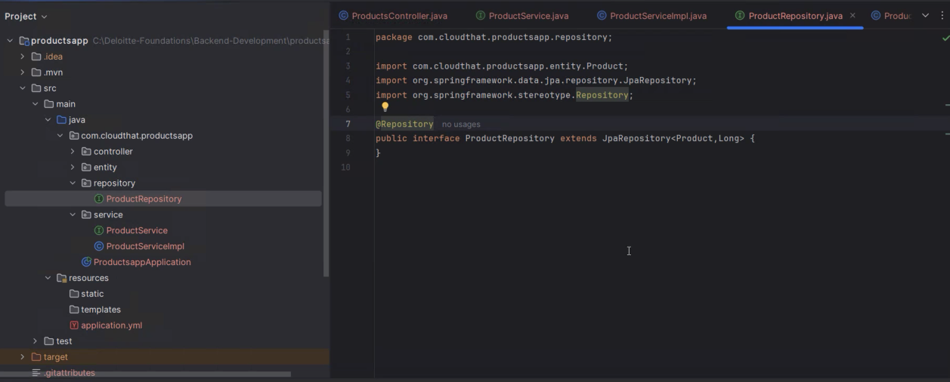

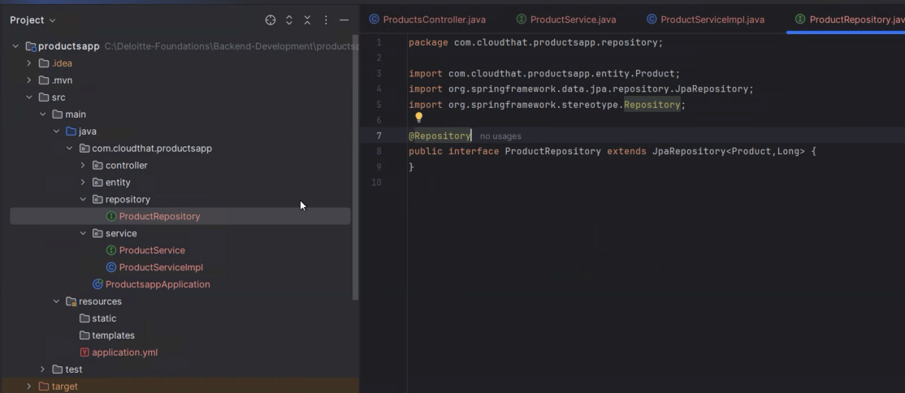

JpaRepository generic which already written

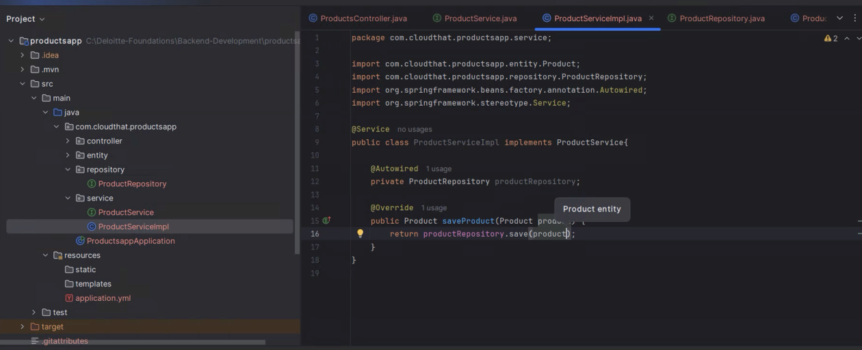

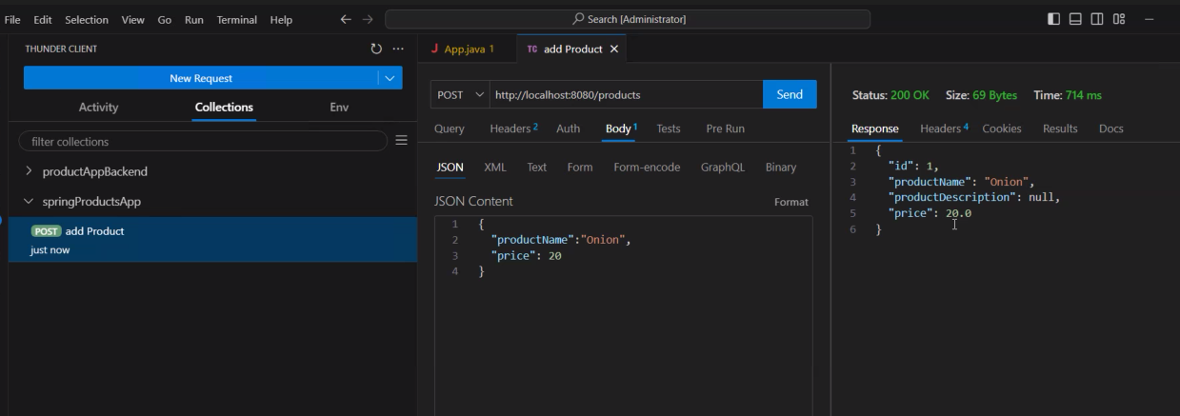

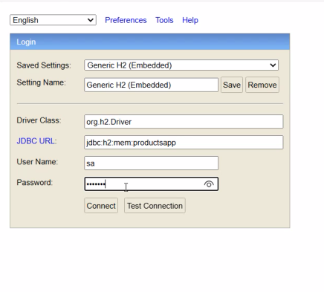

After opening click on connect and type

SELECT \* FROM product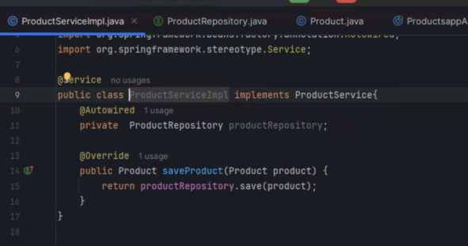

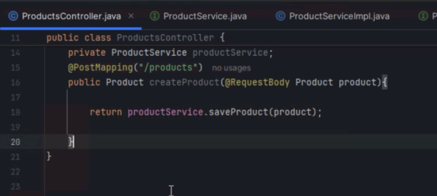x

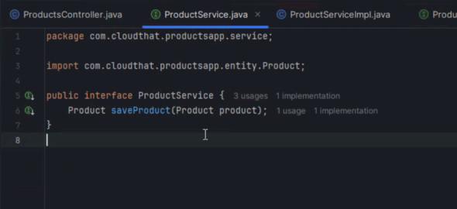

Getting all the products

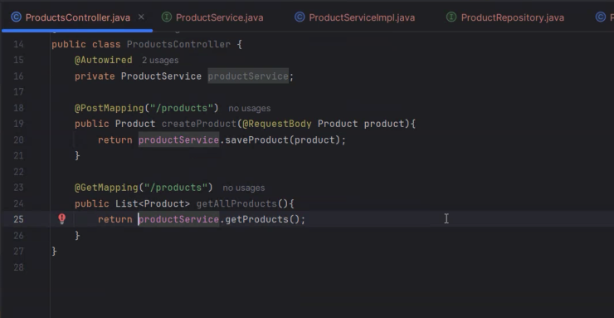

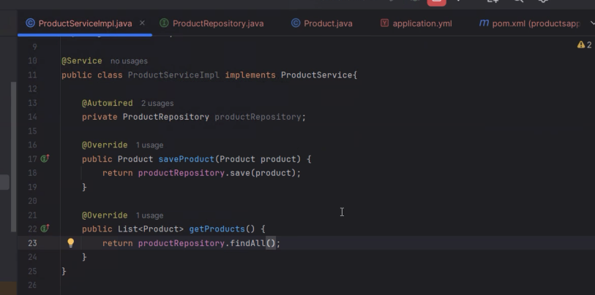

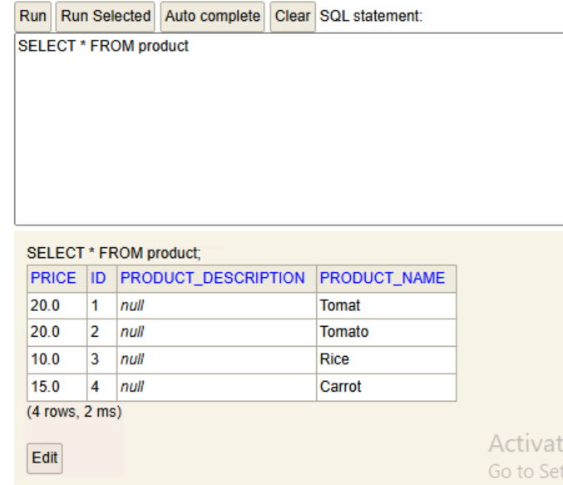

ProductController.java

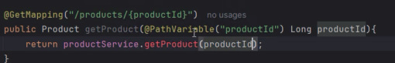

productServiceImpl.java

